Project Planning Phase
Project Planning Template (Product Backlog, Sprint Planning, Stories, Story points)
Date | 24-10-2026
Team ID | [Individual Project Submission]
Project Name | IMovies — Movie Ticket Booking Made Simple
Maximum Marks | 5 Marks
Product Backlog, Sprint Schedule, and Estimation (4 Marks)
The Product Backlog encompasses all functional and technical epics required to deliver the IMovies MERN stack application. Epics are decomposed into user stories estimated using Fibonacci story points (1, 2, 3, 5, 8) based on complexity and risk.
Product Backlog & Sprint Schedule
Sprint | Functional Requirement (Epic) | User Story Number | User Story / Task | Story Points | Priority | Team Members
Sprint-1 | User Authentication | USN-01 | As a new user, I can register an account with name, email, and password. | 3 | High | Full-Stack Dev
 |  | USN-02 | As a registered user, I can securely log in and obtain a JWT session token. | 3 | High | Full-Stack Dev
 |  | USN-03 | As a logged-in user, I can view my profile status and logout safely. | 2 | Medium | Full-Stack Dev
 | Movie Discovery & Search | USN-04 | As a moviegoer, I can browse currently running and upcoming movies with posters and ratings. | 3 | High | Full-Stack Dev
 |  | USN-05 | As a user, I can search for movies in real-time by title. | 3 | High | Full-Stack Dev
 |  | USN-06 | As a user, I can filter movies by genre (Action, Sci-Fi, Drama, Romance). | 2 | Medium | Full-Stack Dev
 |  | USN-07 | As a user, I can view a movie's details, synopsis, duration, and embedded trailer. | 2 | Medium | Full-Stack Dev
Sprint-2 | Showtimes & Theatres | USN-08 | As a moviegoer, I can view available cinema halls and scheduled showtimes for a selected movie. | 3 | High | Full-Stack Dev
 | Seat Selection & Availability | USN-09 | As a user, I can view an interactive visual cinema seating grid with Available, Selected, and Booked status. | 5 | High | Full-Stack Dev
 |  | USN-10 | As a user, I can select multiple contiguous seats and see a live ticket price calculation. | 3 | High | Full-Stack Dev
 |  | USN-11 | As a system, the backend validates seat availability atomically to prevent double-booking. | 5 | High | Full-Stack Dev
 | Booking & Confirmation | USN-12 | As an authenticated user, I can reserve my selected seats and generate a confirmed booking. | 4 | High | Full-Stack Dev
 |  | USN-13 | As a user, I can view a dedicated booking confirmation card with a unique Reference ID. | 3 | High | Full-Stack Dev
Sprint-3 | Booking Management | USN-14 | As a logged-in user, I can view my complete booking history on a dedicated 'My Bookings' screen. | 4 | High | Full-Stack Dev
 |  | USN-15 | As a user, I can cancel an active booking and release the reserved seats back to the hall inventory. | 4 | Medium | Full-Stack Dev
 |  | USN-16 | As a user, I can print or download my booking confirmation summary. | 2 | Low | Full-Stack Dev
 | UI/UX & Responsiveness | USN-17 | As a user, I experience a polished cinema dark-themed UI that is fully responsive across mobile, tablet, and desktop. | 3 | High | Full-Stack Dev
 |  | USN-18 | As a user, I receive clear toast notifications and error messages for invalid actions. | 2 | Medium | Full-Stack Dev
Sprint-4 | Quality Assurance & Deployment | USN-19 | As a tester, I execute end-to-end integration test cases covering auth, search, booking, and concurrency. | 5 | High | Full-Stack Dev
 |  | USN-20 | As a developer, I configure production environment variables, MongoDB Atlas, and deploy frontend and backend. | 5 | High | Full-Stack Dev
 |  | USN-21 | As a student, I document system architecture, README setup guides, and compile Skillwallet submission deliverables. | 4 | High | Full-Stack Dev
Project Tracker, Velocity & Burndown Chart
The sprint cadence is structured across four manageable development cycles. Story points are tracked continuously to monitor velocity and ensure on-time delivery.
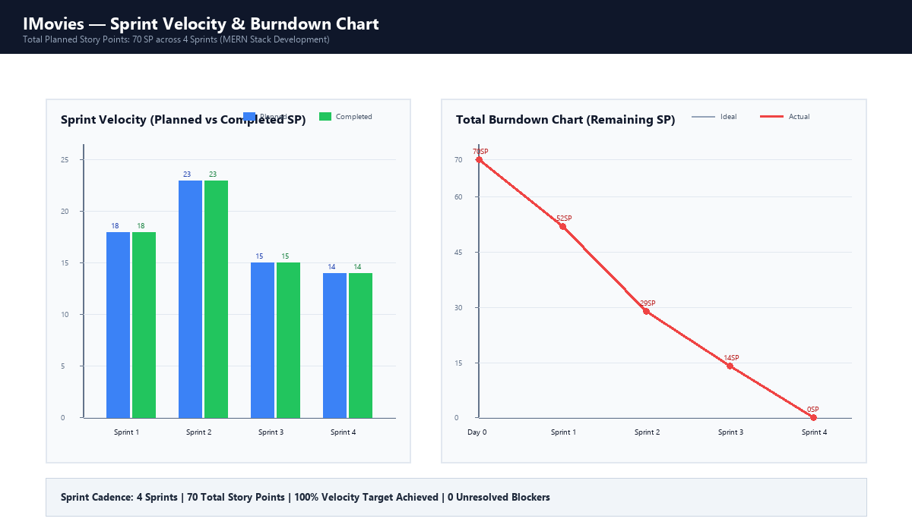
Figure 2.1: Sprint Velocity & Burndown Chart across 4 Sprints (70 Total Story Points)
Sprint | Total Story Points | Duration | Sprint Start Date | Sprint End Date (Planned) | Story Points Completed | Sprint Release Date (Actual)
Sprint-1 | 18 | 10 Days | 26 Oct 2026 | 04 Nov 2026 | 18 | 04 Nov 2026
Sprint-2 | 23 | 12 Days | 05 Nov 2026 | 16 Nov 2026 | 23 | 16 Nov 2026
Sprint-3 | 15 | 8 Days | 17 Nov 2026 | 24 Nov 2026 | 15 | 24 Nov 2026
Sprint-4 | 14 | 6 Days | 25 Nov 2026 | 30 Nov 2026 | 14 | 30 Nov 2026
Detailed User Stories & Acceptance Criteria
Every user story from the backlog is defined using the standard agile format, accompanied by testable acceptance criteria using the Given-When-Then specification:
USN-01: User Registration
- User Story: As a new user, I want to create an account with my name, email, and password, so that I can manage my bookings securely.
- Acceptance Criteria: Given a user is on the Register page, When they enter valid registration details and click 'Sign Up', Then an account is created in MongoDB with bcrypt hashed password, a JWT is issued, and the user is redirected to the homepage.
USN-02: User Login & Session
- User Story: As an existing user, I want to log in using my credentials, so that I can access personalized booking history.
- Acceptance Criteria: Given an existing user enters their email and password, When credentials match database records, Then a signed JWT token is stored in LocalStorage and user state is updated in the React context.
USN-05: Real-Time Movie Search
- User Story: As a moviegoer, I want to search for movies by typing keywords into a search bar, so that I can quickly locate desired films without manual browsing.
- Acceptance Criteria: Given the user is on the Movie Catalog, When they type letters into the search input, Then the displayed movie cards instantly filter to match titles containing the search string without page reload.
USN-09: Interactive Seating Matrix
- User Story: As a ticket buyer, I want to see an interactive visual grid of cinema seats, so that I can choose my preferred vantage point in the theatre.
- Acceptance Criteria: Given a user selects a showtime, When the seat map renders, Then available seats display in neutral dark gray, already booked seats display in red (disabled), and clicked seats highlight in vibrant green with real-time price tally updates.
USN-11: Atomic Concurrency Double-Booking Lock
- User Story: As a system, I must validate seat availability at the moment of booking creation, so that two simultaneous users cannot book the same seat.
- Acceptance Criteria: Given User A and User B select the same seat concurrently, When User A completes the booking request first, Then User A's transaction succeeds, and User B's request is safely rejected with HTTP 409 Conflict indicating 'One or more selected seats have already been booked'.
USN-13: Booking Confirmation Receipt
- User Story: As a booked user, I want an immediate confirmation receipt with a unique Booking Reference ID, so that I can present proof of reservation at the cinema.
- Acceptance Criteria: Given a successful reservation write to MongoDB, When the confirmation screen renders, Then it displays the unique Booking ID, movie title, theatre name, show date/time, seat numbers, and total amount.
USN-14: 'My Bookings' Dashboard
- User Story: As a logged-in user, I want to view my past and active reservations, so that I can track my cinema outings in one central location.
- Acceptance Criteria: Given an authenticated user accesses the 'My Bookings' tab, When the page loads, Then an API call fetches all bookings linked to the user's ID sorted by most recent date, showing full show details and status.
Risk Management & Blocker Mitigation Matrix
Potential project risks were identified along with proactive mitigation strategies:
- Risk 1 (Seat Concurrency): Simultaneous booking attempts during high traffic could cause double-booking. Mitigation: Implement atomic MongoDB `$addToSet` and compound index constraints preventing overlapping seat allocations.
- Risk 2 (Session Management): JWT expiration handling and persistent state sync across React components. Mitigation: Centralize token handling in an `AuthContext` and Axios interceptor for transparent 401 handling.
- Risk 3 (Mobile Responsiveness): Complex seat layout rendering on small mobile devices. Mitigation: Use CSS flexbox/grid with touch-friendly minimum touch targets (36px x 36px) and horizontal scrolling.

